
Beccles Library
Are you a budding author, or just enjoy listening to others
reading and discussing their work?
If so, we would like to introduce you to our
Creative Writing Group
which meets on the first Tuesday of each month
from 2.00 pm - 4.00pm
The next meeting is Tuesday 1st August.
New members welcome.
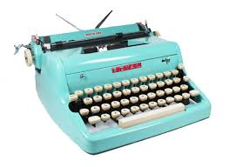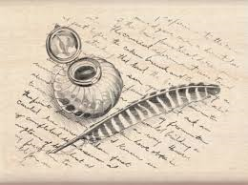

We also have a thriving Poetry Group which meets
on the last Friday of the month, from 2.00-3.00pm.
The next meeting is on Friday 25th August.
Some like to write their own poetry, whilst others just listen to what poets have written.
Please feel free to come along and join us.
Talk, listen and maybe learn about poetry, rhyme and style.

